**Westgate Surgery Newsletter**

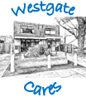

**January 2021 Edition**

2021!

We hope everyone’s New Year is going well so far. 2020 was difficult for many, but we are looking forward to a positive 2021 and being able to provide Covid-19 vaccines to patients in line with guidance from NHS England.

Covid-19 Vaccinations

We have started to vaccinate the first wave of patients who are over the age of 80. We will work through the government’s groups of patients and invite patients for a vaccination as we get access to the vaccines. Please do not contact us but please do make sure that if you have changed your phone numbers, particularly any mobiles, we have the correct contact details. We will keep updating our Facebook page with information regarding the vaccines and how far we are progressing through the groups.

Sadly one of our nurses, Amanda, left at the end of the year. She is now working for Public Health England and we wish her much luck.

Our new nurse, Tracy, started this month.

We have had a change round of roles and responsibilities and nurse Julia will now be looking after our diabetic patients.

We now have regular clinics for social prescribing. This is managed by Michele our patient champion who can help anyone with loneliness, debt or non-medical problems and concerns that may be affecting your wellbeing. She has clinics on Wednesday and Thursday afternoons. Please ask reception for an appointment.

Thank you for helping us out through a difficult year by continuing to wear masks and minimising coming to the surgery. Until we have completed Covid vaccinations and the rate of infections have reduced, we will need to continue to do this.

Staff Changes

Social Prescribing

Thank you!

Gold Standards Framework Awards 2020

We are very proud to say that we have been given a Gold Standards Framework award in recognition of the work we have done to support those at the end of life.

The surgery was given a plaque to recognise this work at a virtual meeting. The practice reviewed how it offers patients care at the end of life including the provision of end of life medications and direct access to additional support. We have also reviewed the care we offer the family of the deceased and provide information on bereavement to all family members after they lose a loved one.

As a team, we are honoured to accept this award and are extremely grateful for our work to be recognised.

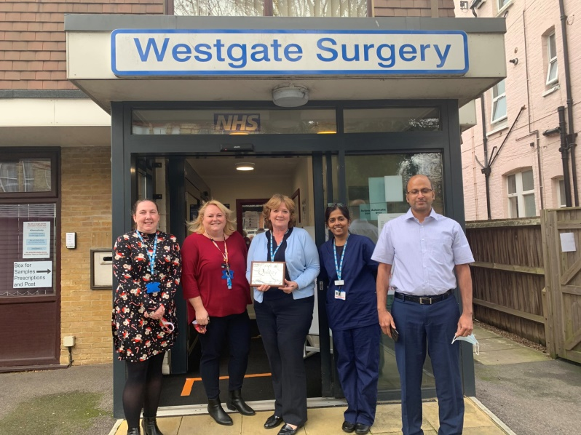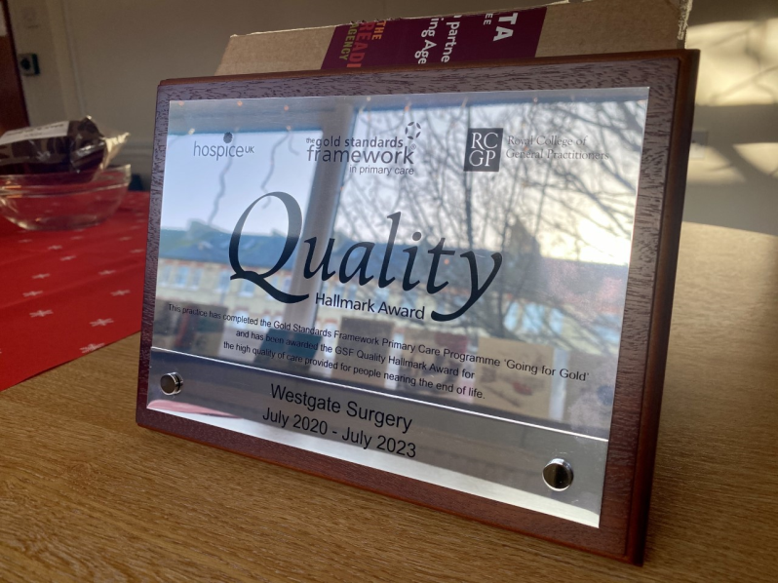

If you would like help with giving up smoking, please ask and we can refer you to the ‘One You’ support service.

Or if you would like to exercise more, please look at the couch to 5k app: https://www.nhs.uk/live-well/exercise/get-running-with-couch-to-5k/

The surgeries resolution that we are all making as a team, is to be positive and reactive again. So much of 2020 has been put on hold but we now feel that we can begin to implement new initiatives and changes again. We look forward to telling you more in future newsletters. We hope that later in the year we will begin to meet again with our patient group.

Resolutions