  - 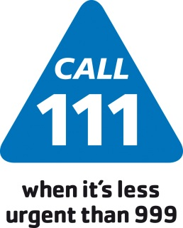

  - Prescribing of over the counter medicines in changing

You’re GP, nurse or pharmacist will not generally give you a prescription for over the counter medicines for a range of short-term, minor health concerns. Instead, over the counter medicines are available to buy in a pharmacy or supermarket in your local community. The team of qualified healthcare professionals at your local pharmacy can offer clinical advice to safely and effectively manage minor health concerns.
This includes the items below:

Acute sore throat | Conjunctivitis | Coughs, colds and nasal congestion | Cradle cap
Dandruff | Diarrhoea (adults) | Dry eyes / sore tired eyes | Earwax
Excessive sweating | Haemorrhoids | Head lice | Indigestion and heartburn
Infant colic | Infrequent cold sores of the lip | Infrequent constipation | Infrequent migraine
Insect bites and stings | Mild acne | Minor burns and scalds | Mild cystitis
Mild dry skin | Mild irritant dermatitis | Mild to moderate hay fever | Mouth ulcers
Nappy rash | Oral thrush | Prevention of tooth decay | Ringworm / athletes foot
Sunburn | Sun protection | Teething / mild toothache | Threadworms
Travel sickness | Warts and verrucae | Minor pain, discomfort and fever (e.g. aches and sprains, headache, period pain, back pain)

For more information and support visit the NHS website, nhs.uk/OTCmedicines

