Please call the surgery if you have any problems on
01843 831335.

Approved Date: 07/11/2017
Review Date: 12/07/2019
Date of Next Review: 14/03/2022
Westgate Surgery

Audiology
&
Hearing Aid Service

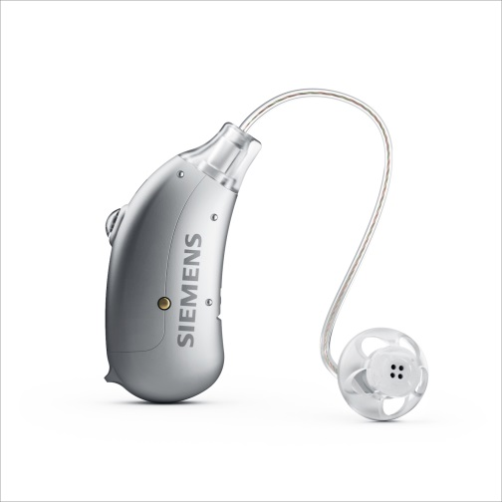
Patient Information Leaflet

Referrals
Once you have been referred to our audiology clinic we are happy to see you for up to three years, once these three years have passed we request you ask you’re GP for a new referral with up to date medical history.
Information about the appointment
A full hearing test will be carried out, this is painless and normally takes around 15 minutes. The test consists of you wearing headphones through which you will hear sounds of different frequencies, some of these sounds are high tones and others are deeper. During the hearing test you will be asked to press a button when you hear them. Depending on the type and amount of hearing loss present, would determine the type of aid and ear mould needed to help. A measurement of your ear might be required to ensure a good fitting. The aids are small and worn behind the ear; they are very easy to use and ideal for people who may have some handling difficulties
Text Reminders
We have a text reminder service; you will receive a text the day before your appointment, so please inform us of your current mobile number.
Appointments
If you do not attend 3 or more appointments you will be discharged back to the care of your GP and another referral will need to be issued.
Battery’s & Battery Books
We supply you with a battery book, a pack of batteries and a cleaning wire, if you need some more batteries for your aid please feel free to ask reception and they will supply you with some, you will need to bring your book when asking for batteries as reception will need to sign it.
Hi Kent – Free Hearing Aid Aftercare Clinic
Hi Kent service is here at Westgate Surgery on a Monday 2pm – 3pm, this is a walk in clinic which will help you with any small issues you have with your hearing aid, please ask reception when you arrive they will give you the information you need. Hi Kent also have clinics in Birchington, Margate, Cliftonville, Ramsgate and Broadstairs please feel free to ask if you require further information, or if you would like to look online the web address is http://www.hikent.org.uk/
Change of details
Please inform us of your new home address, telephone number or if you change GP surgeries.

NHS Hearing Aid
The hearing aids remain the property of the N.H.S. and are only on loan. Should an aid be lost or damaged a charge may be made to replace or repair it.

